

Account Holder Guide

Managing Online Account

**User Guide**

Version 1.0

Table of Contents

1 Introduction 3

2 Purpose 3

3 Initial Screen 3

4 View invoice 6

5 Make payments 7

6 Advanced searches 9

# Introduction

Welcome to the NSW Land Registry Services **myAccount** Service.

The **myAccount** services portal provides a detailed view of your current and historical financial transactions that have been made with the NSW Land Registry Services up to the previous 12 months.

The **myAccount** service portal also allows you to download PDF versions of Invoices and Credit Notes, as well as being able to pay your invoices via an On-Line Credit Card Payment facility.

# Purpose

The purpose of this document is to give a brief overview of the **myAccount** service portal. To show what the screens look like, what information can be found and how to use the service.

# Initial Screen

<https://online.nswlrs.com.au>

Select Authorised User Log in.

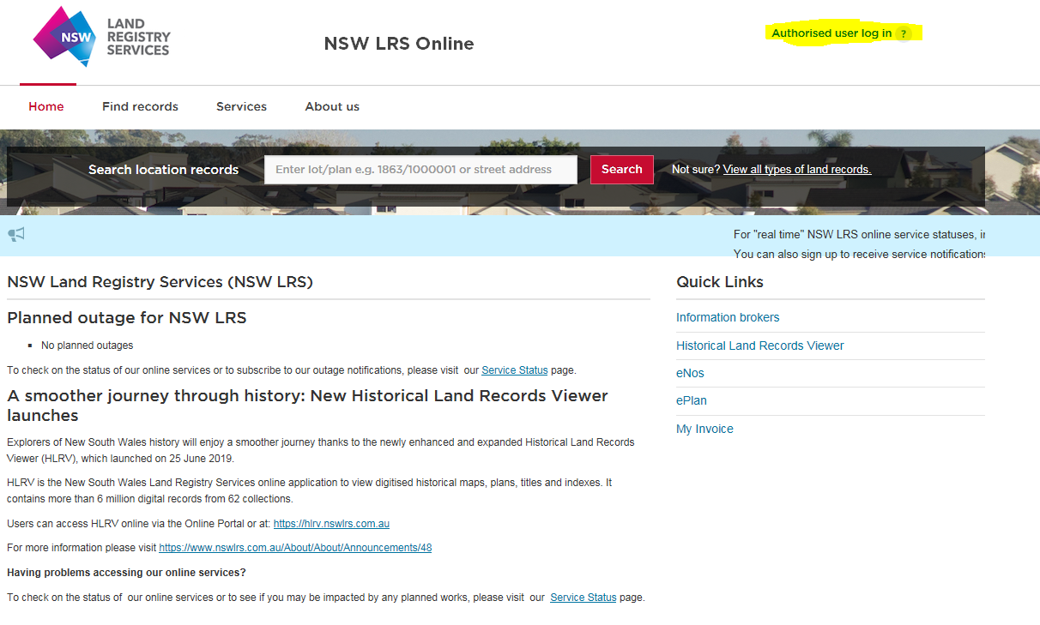

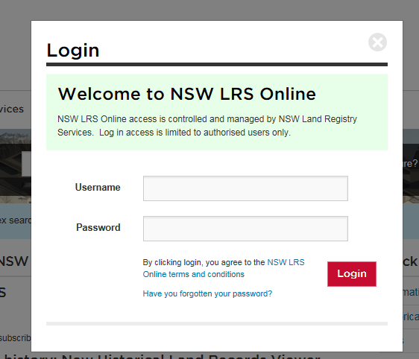With your Username and Password, log into the NSW LRS Online portal.

On your name in the Header section, select **My Account** from menu box.

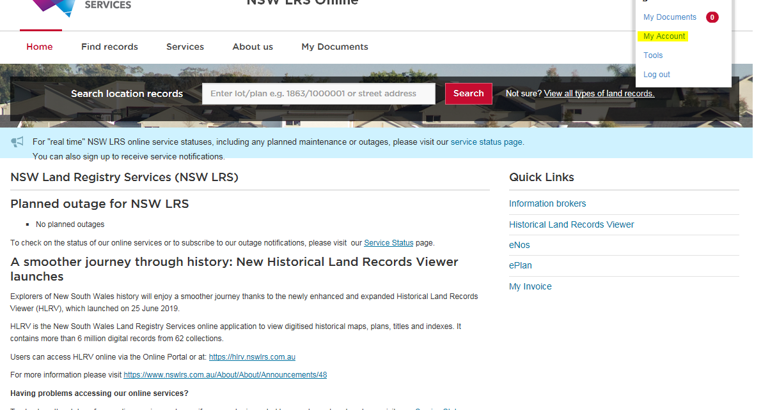

Scroll down to **View account transactions and make payments** button.

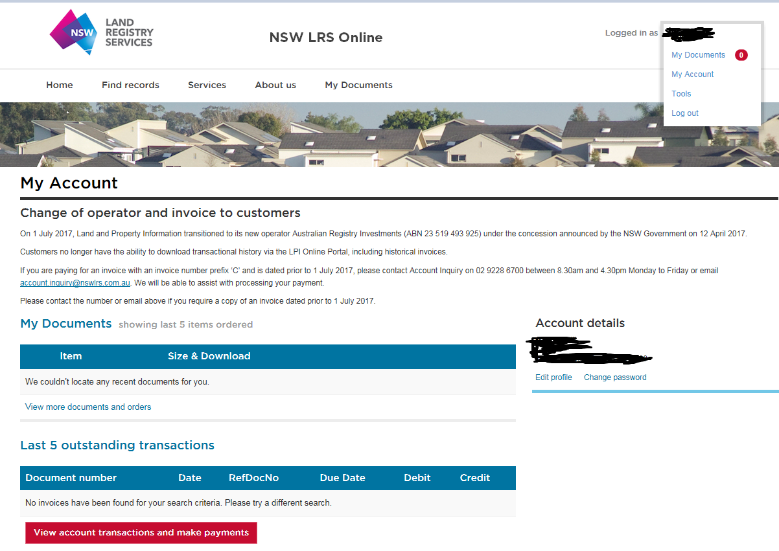

Select your account number from the drop down list.

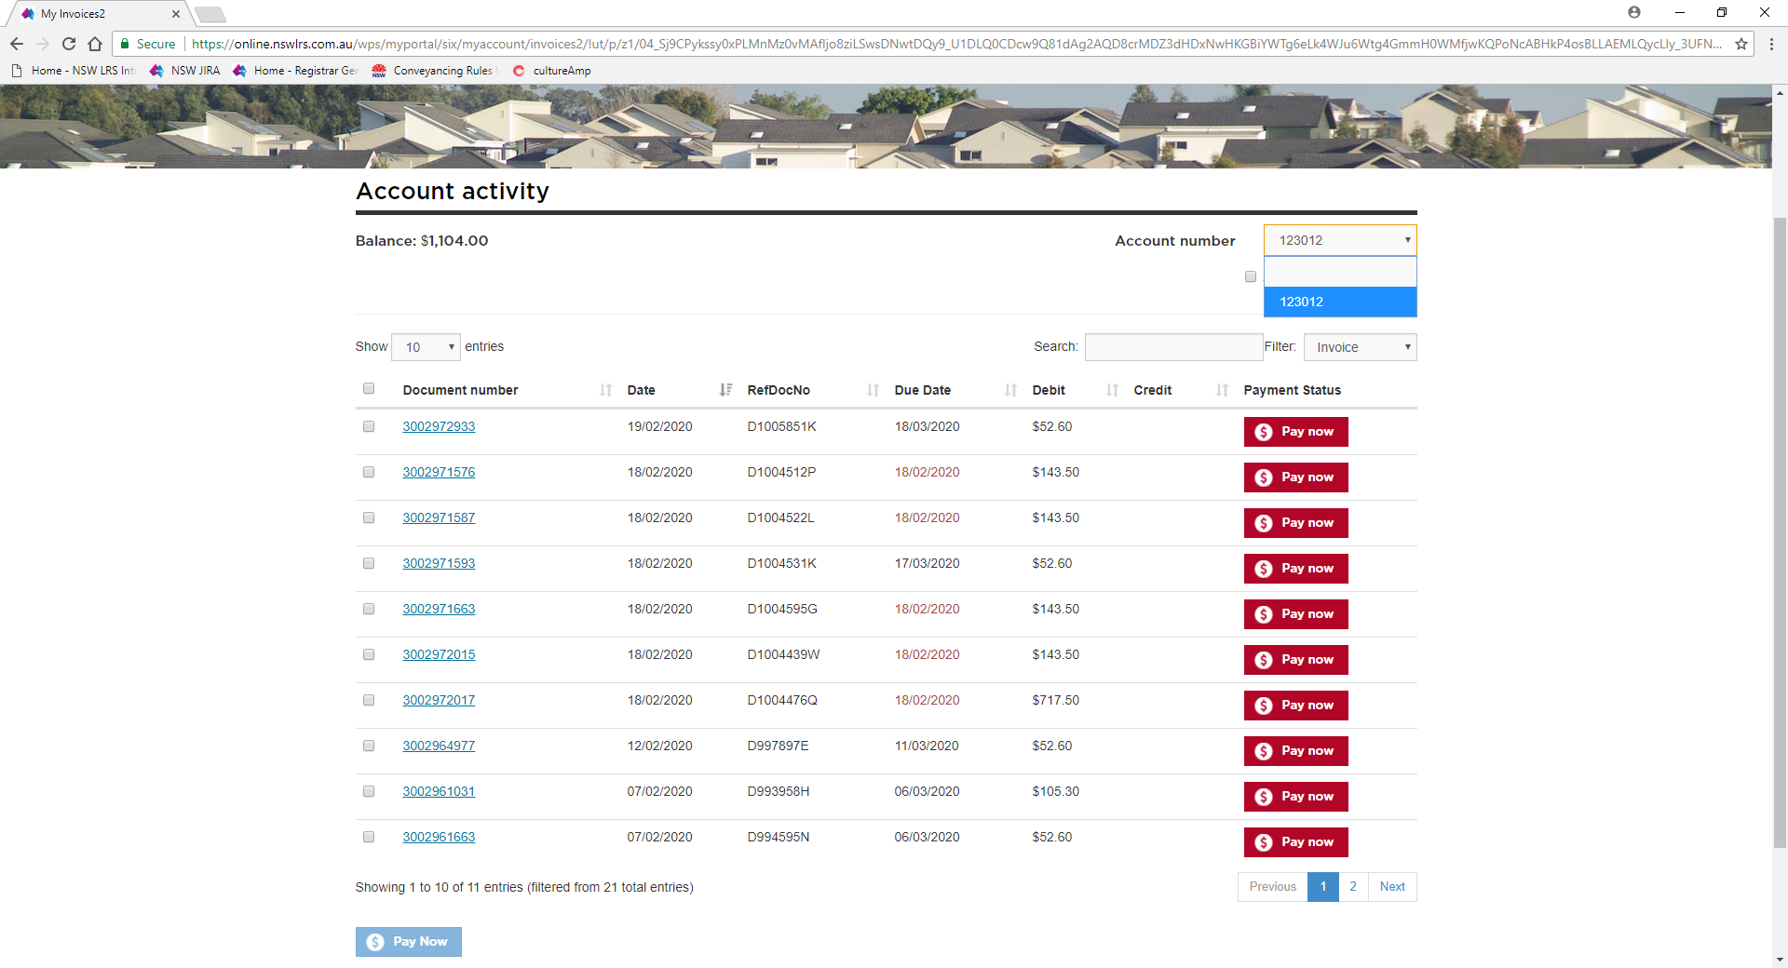

# View invoice

To view a copy of your invoice, double click on the blue document number.

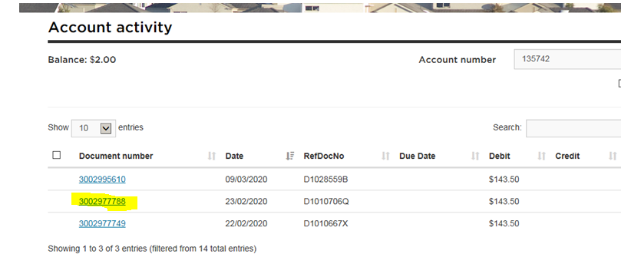

Then select open or save. You can open as a PDF document or save it in a directory.



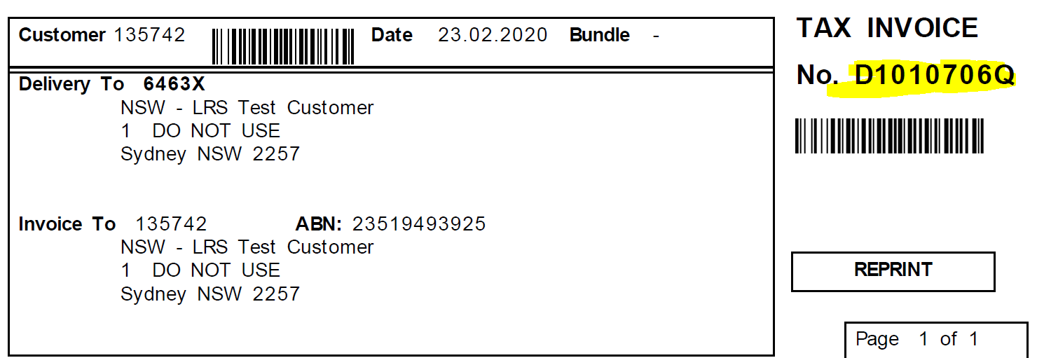

# Make payments

Within **MyAccount** you can pay for multiple invoices and use credits on your account to offset against invoices.

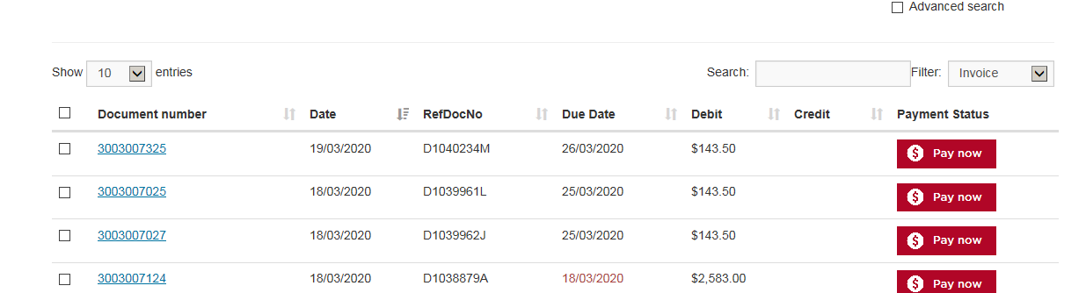

The default screen will show your most recent invoices and will display 10 line entries. You can change these displays by selecting the filter and change from invoice to All.

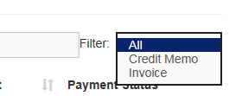

To display more than 10 entries select **show** and select from the drop down options.

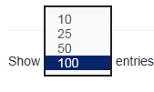

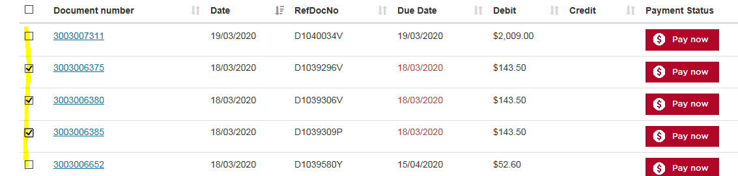To make a payment, select the radio button **Pay now**, to make multiple payments select the box next to the document number shown in yellow.

To use a credit note, select the box for the credit. Note: if no box available/visible, you are unable to use that credit.

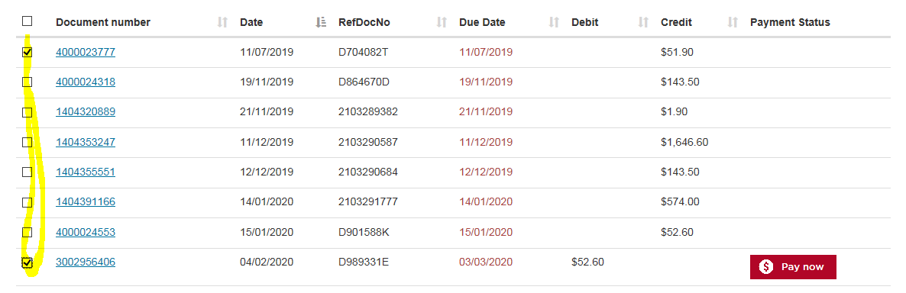

After you have selected your entries select the **Pay now** button at the bottom of the page.

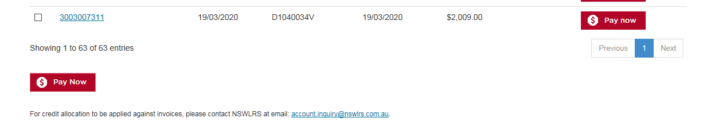

This will take you to the review and payment screen, where you review your selections and enter your credit card details.

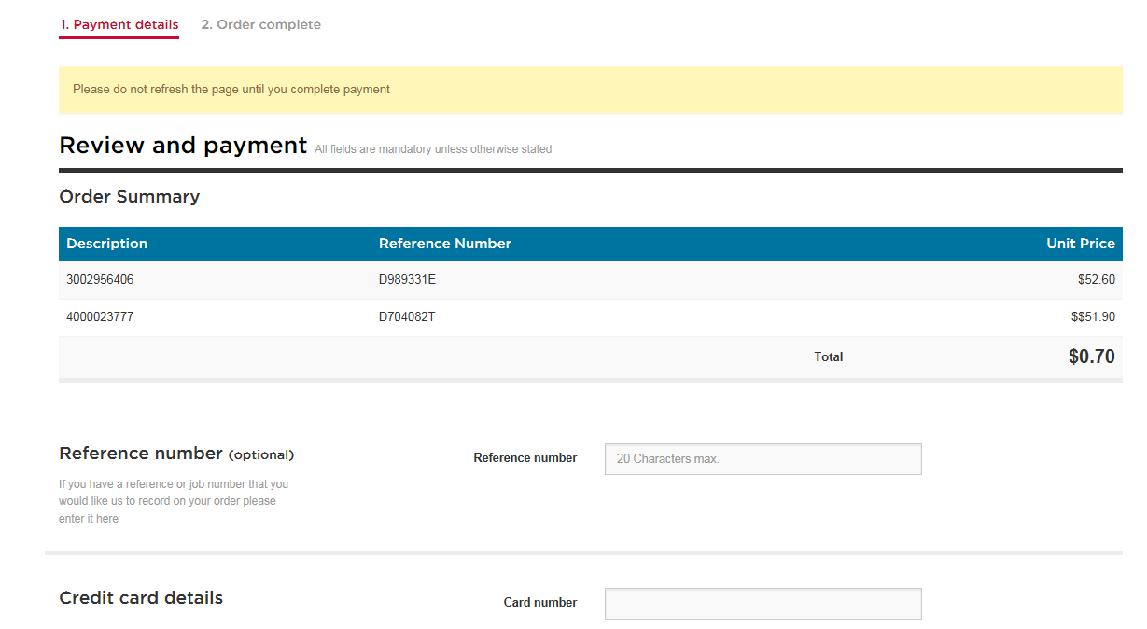

# Advanced searches

You are able to display and print invoices for the previous 365 days or search for specific invoices.

Select the **Advanced Search** button.

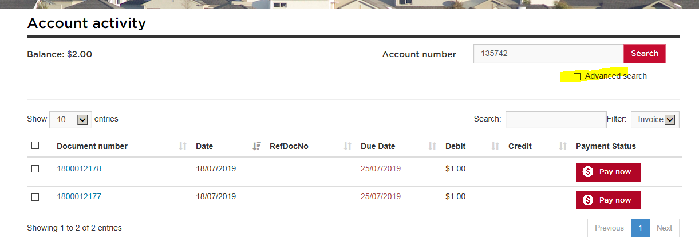

The default screen will display as per below; Choose from the date range options.

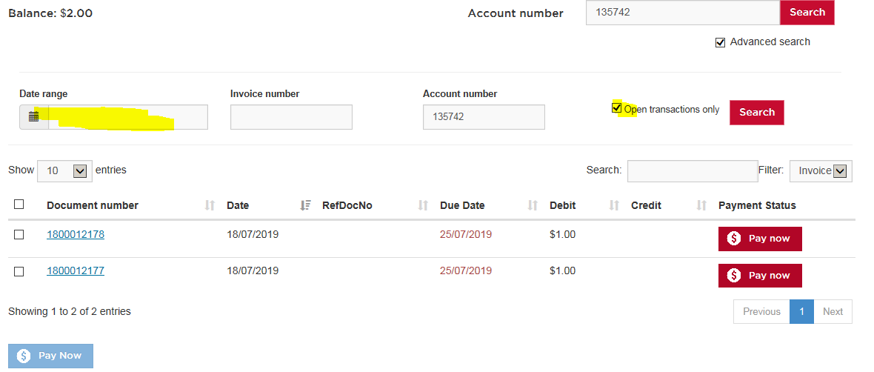

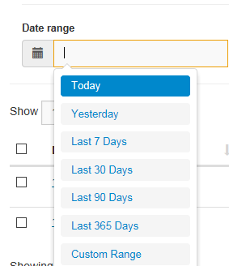

Deselect the Open transations only button.

You will notice that if the invoice has been paid, and the box available is not longer visible to select for payment.

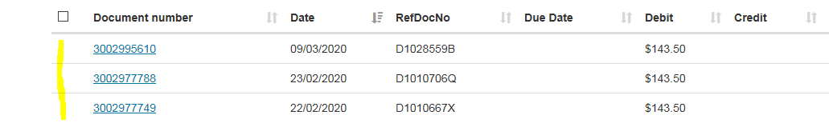

**

To search for a specfic invoice enter the invoice number in the **Invoice number** box.

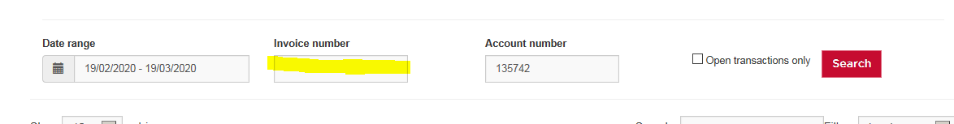

When completed, log out of the NSW LRS Online Portal.